Protocol for skull mesh extraction from cbct images

Contents
REQUIRED APPLICATIONS: 1
3D SLICER 2
Segment the Skull from the CBCT 3
BLENDER: Shrink-wrap the skull 8
MESHMIXER to reduce/remesh 10

REQUIRED APPLICATIONS:
- 3D slicer Program (www.slicer.org)
- Blender
- Meshmixer
- DICOM images (.DCM) per individual in a folder

3D SLICER
- Open 3D slicer.
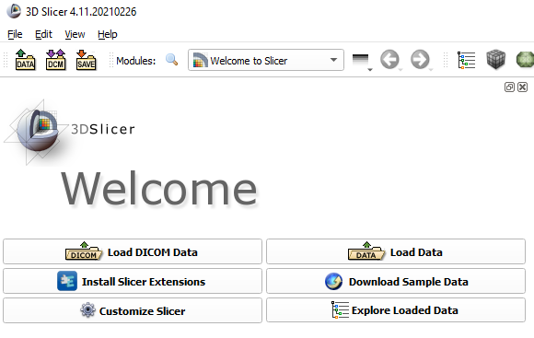
- On the welcome page there is an option for “Load DICOM Data”.
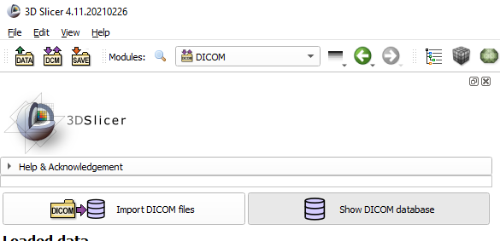
- Select “Import DICOM files”.
- In the pop-up, select the folder which contains the around 450 .DCM images and choose “import”.
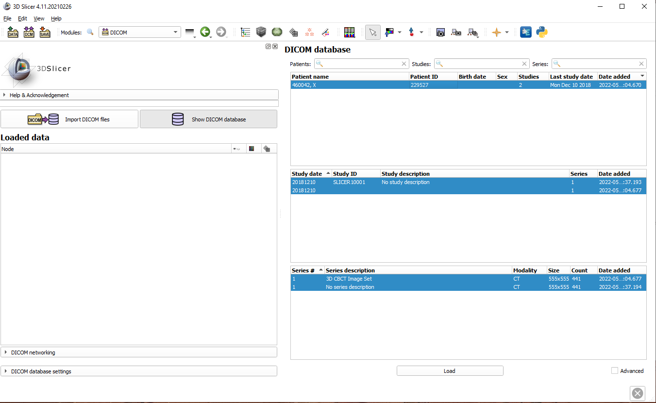
- Your patient will be listed in the DICOM Database on the right side of the screen.
- Double click the patient ID to load the files, you should see the CBCT images on the right.

Segment the Skull from the CBCT
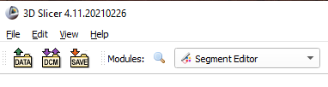
- Switch the Module to “Segment Editor”.
- Add 2 segments. Click Segment 1 and select “Threshold” as the Effect.

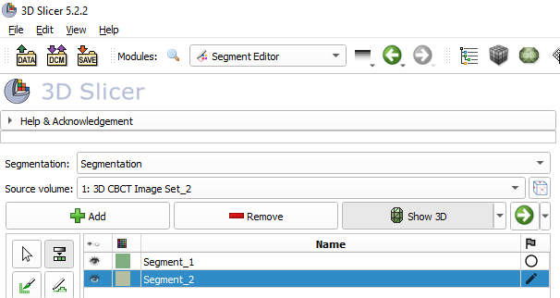

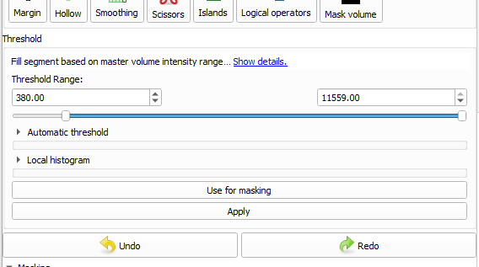
- Under Threshold, select around 380 Hounsfield Units (HU) as the lower limit and make sure the upper limit is set to maximum. Select “Apply”.

- Visualize the skull in the right-hand window by selecting “Show 3D”. Adjust the lower limit between 380 HU and 600 HU for optimal visualization of the skull mesh in the upper right-hand window. Pressing “Apply” for the threshold will automatically update the 3D image. You are looking for a complete skull but without too many artefacts, particularly on the teeth.
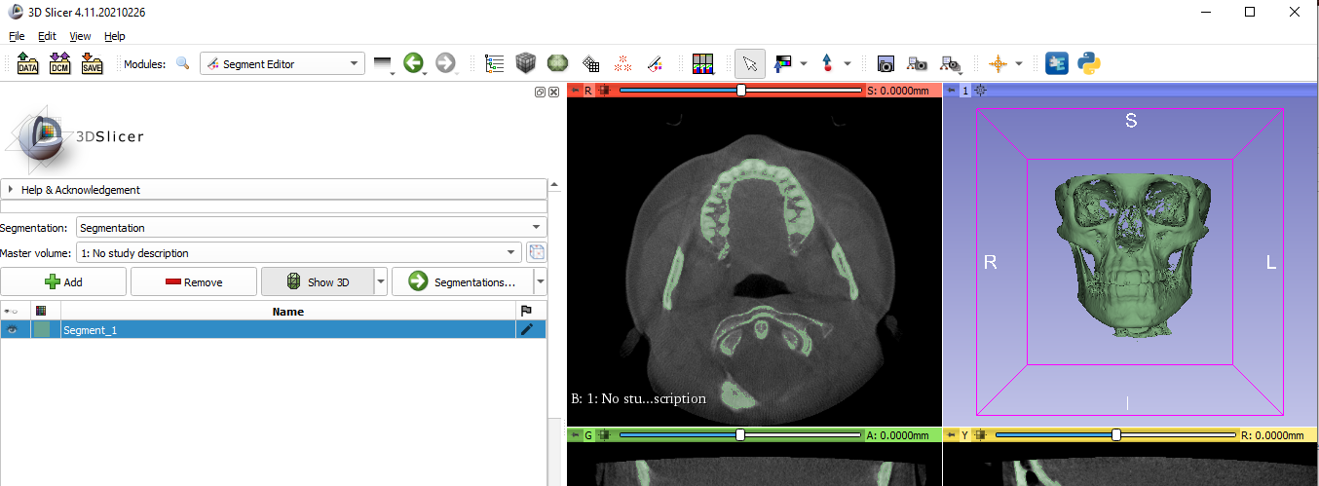
- Under Effects, select “Islands” as the effect, select “Keep larger island” and click “apply”.

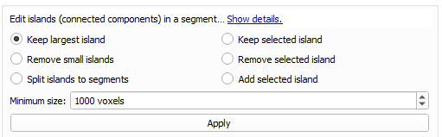
  - **Take note to ensure no skull structure is lost in this action, only the spine structures are removed. If too many are removed, use “remove small islands” and increase size until the spine structures are all gone.
- Under Effects, select “Scissors” as the effect, and remove any debris present on the skull
  - **Better to not remove enough than to remove too much, err on the side of caution and preserve as much skull structure as possible. You can also use this to remove any remaining spine.
- Under Effects, select “Islands” as the effect, select “remove small islands” and click “apply”.

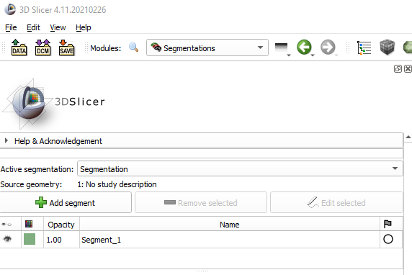
- Switch the Module to “Segmentations”. Segment 1 should be listed. Click on Segment 1 to select.
- Select the drop-down menu under Active Segmentation and choose “Rename Current Segmentation”. Rename to the ID of the sample.
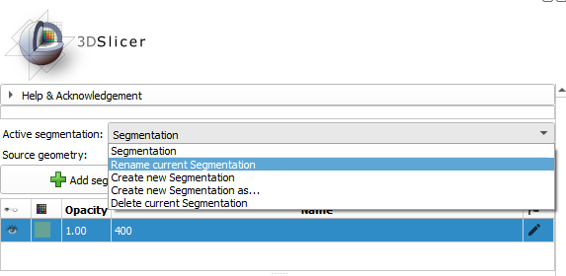

- Scroll down in the options below to “Export to Files” and expand this menu. Select a destination folder and select “OBJ” under File Format. Select “Export” to Export.
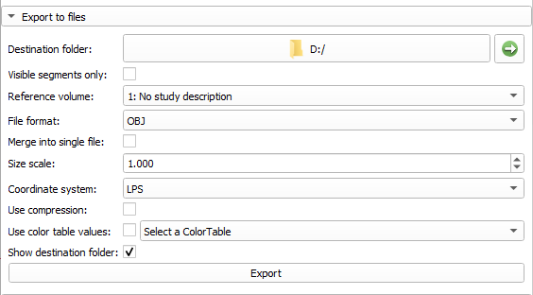

BLENDER: Shrink-wrap the skull
- Open Blender
- Select File > Open the supplementary file “ShrinkWrapSkull.blend”
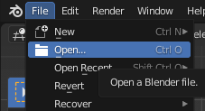

- Select File > Import > Wavefront (.obj) > Skull Object > import
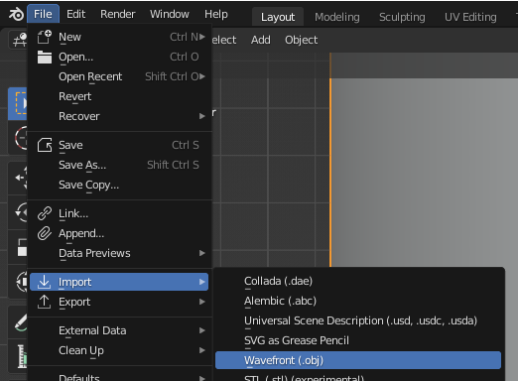
- Rotate Skull (keys “R”, “X”, “-90”) so that it is facing forward
- Select Cylinder object
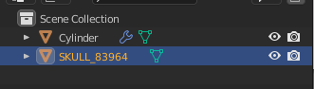
- select wrench tool, you should see multiple modifiers, find all the ones that say shrink wrap: Shrinkwrap > Target > select “SKULL_...” [6 total]
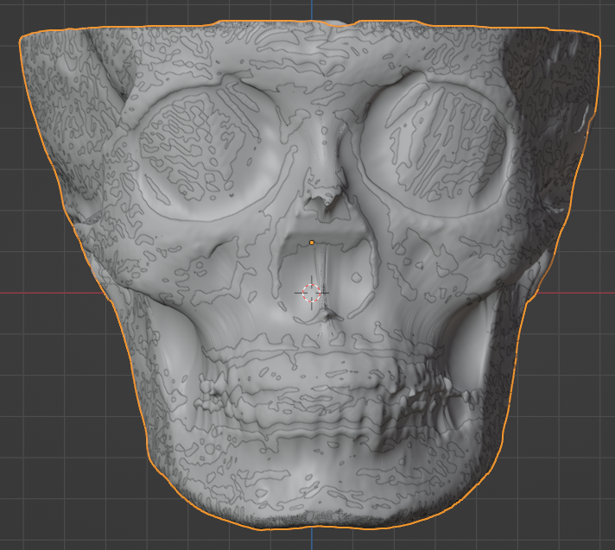
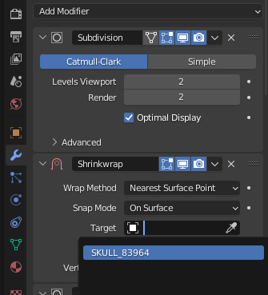
- Select File (cylinder) > Export > Wavefront (.obj) MAKE SURE THE SETTING “selection only” IS ON> Save
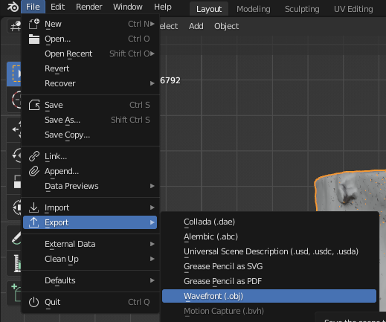

MESHMIXER to reduce/remesh
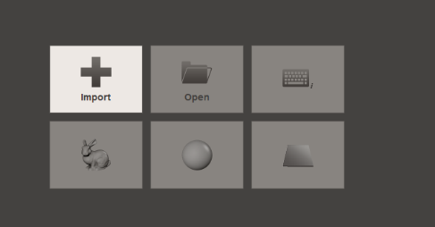
- Select Import
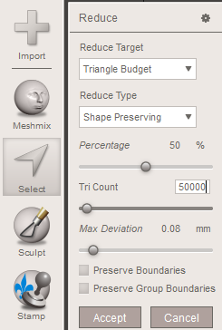
- Import shrink-wrapped skull object from Blender pt. 2
- Select Object (“Ctrl” + “A” to highlight orange) > Edit > Reduce . . .
  - Reduce Target > Triangle Budget
  - Untick “preserve boundaries” box
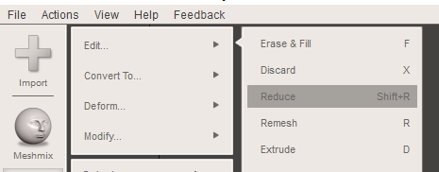
  - Change tri-count to 50,000 > “enter”

- Click “Accept”
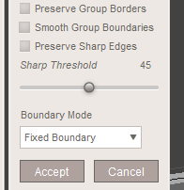
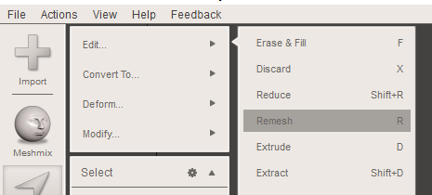
- Select Object > Edit > Remesh > Untick “smooth group boundaries” > click “Accept”
- File > Export > Save as .obj
- Continue on to Meshmonk!

